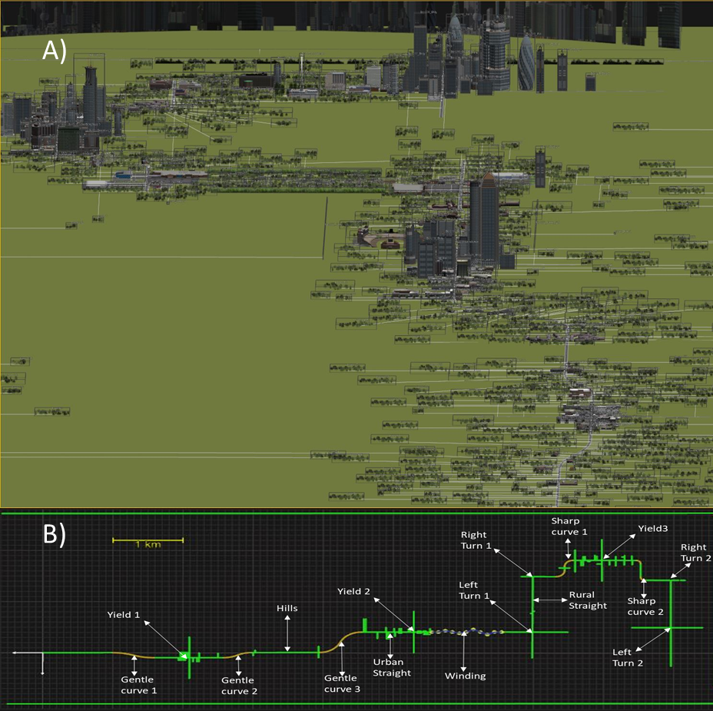

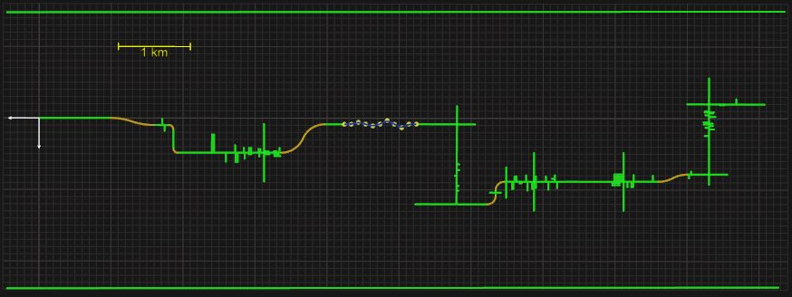

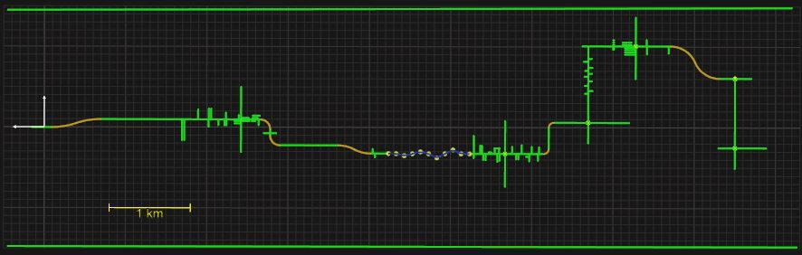

*Figure 2. 2* Aerial view of Drive 1 (A) and top-down view of the road networks for Drive 1, with all scenario elements labeled (B). Drive 2 and 3 contained the same scenario elements as Drive 1 but presented in different orders.